Nepal College of Information Technology
First Term Test
ELX 213.3 Electronic Devices
F.M. 70
Attempt all the questions.

1(a) Differentiate between linear and non-linear circuits. State different methods to analyze non-linear circuits. [8]
1(b) Find the current through the load resistor, R_{L} and power dissipated in the load for the circuit shown in figure 1. [7]
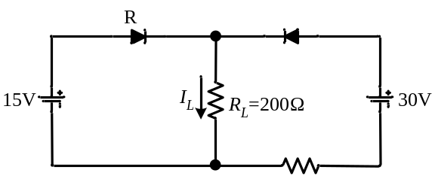
Figure 1
2(a) Discuss pn junction diode under forward bias. [10]
2(b) Differentiate between transition capacitance and diffusion capacitance. [5]
3(a) Discuss the phenomenon of reverse breakdown in a pn junction diode. Explain zener diode as a voltage regulator. [7]
3(b) Explain the operation of a full wave bridge rectifier. What are the disadvantages of a center tapped full wave rectifier? [8]
4(a) Explain the operation of the clipper circuit shown in figure 2 and sketch the output waveform for an input v_{i}(t) = 10 sin(ωt). [7]
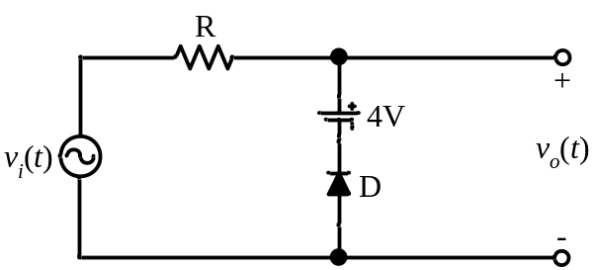
Figure 2
4(b) (i) Find the average value and the percent ripple in the load voltage in figure 3(a).
(ii) Repeat (i) when an RC filter is inserted between the capacitor and the load as shown in figure 3(b). [8]

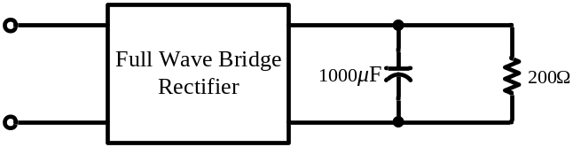
Figure 3(a)

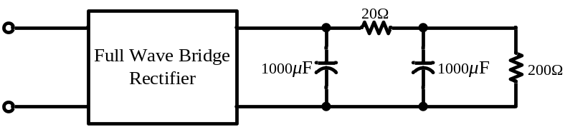
Figure 3(b)
5 Write short notes(Any Two) [5x2]
(a) Piecewise linear circuit
(b) Clamper Circuits
(c) Varactor diode
(d) Semiconductors

